- Get ready to use UDOIT. Go to Settings>Navigation to pull the UDOIT app into the top navigation area.
(Students will not be able to see this).

- Run UDOIT by clicking on the left navigation button.
- Select elements to scan (see screenshot below).
- Scan for both errors and suggestions.
- Click “Scan this course”. Do not leave the page while it is being scanned.
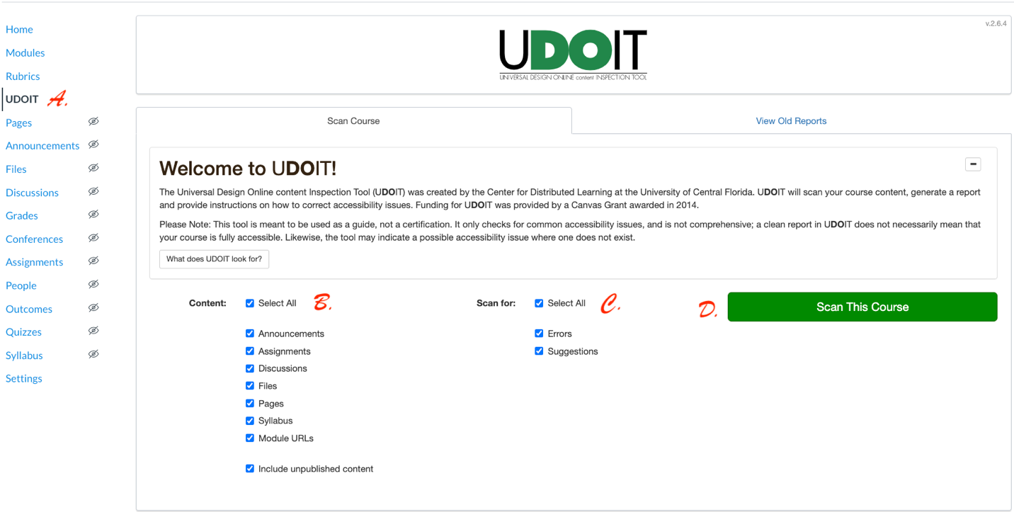

- The resulting page outlines the errors versus suggestions. The elements associated with the errors and suggestions are under the “Summary” column and are linked. Click these for fixes.

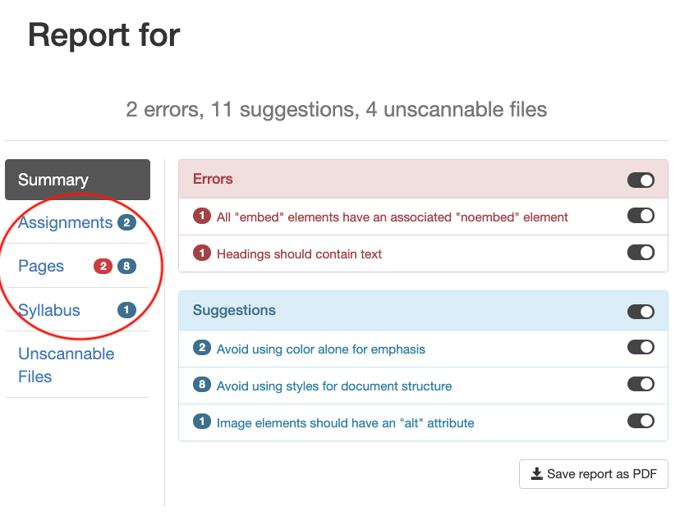
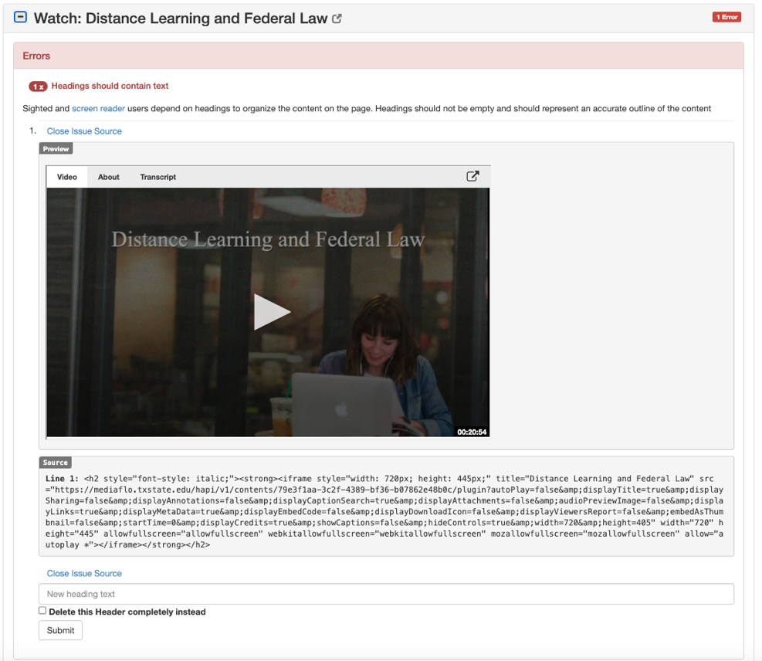
- UDOIT not only identifies errors, but allows you to preview the problem and fix it on the same page. Find the line items in the list with a red error label.

Click on the plus sign to the left of the line item title to expand the section for more information.

Click on:

Fix the issue.

Attend to the identified errors immediately. Then, follow-up with the suggestions.

