Using Flipgrid in Canvas – For Instructors
(Before LTI integration by the university)
Setting up Flipgrid 1
Groups 1
Topics 2
Embedding Flipgrid into Canvas 4
Group 4
Topic 4
Uploading/Recording to Flipgrid (as an instructor or student) 5
Alternatives to Video 7
Responding to Students in Flipgrid 7
Sharing a Microsoft 365 Document 8

Setting up Flipgrid

Groups

- Go to www.flipgrid.com.
- Create an educator account by clicking on Educator Signup.
- Click “Add New Grid.” Title it and choose the “School Email” grid type. Ignore the Flip Code for now. Click Next.
- Groups
  - Create a “Group” for your class.
  - Suggested: Leave the join code as default
  - Keep your groups private.
  - Provide to students via “Student Email.”
  - Add “@txstate.edu” to the space provider. Or, keep the security even tighter by uploading a list of names and email addresses via a CSV file.
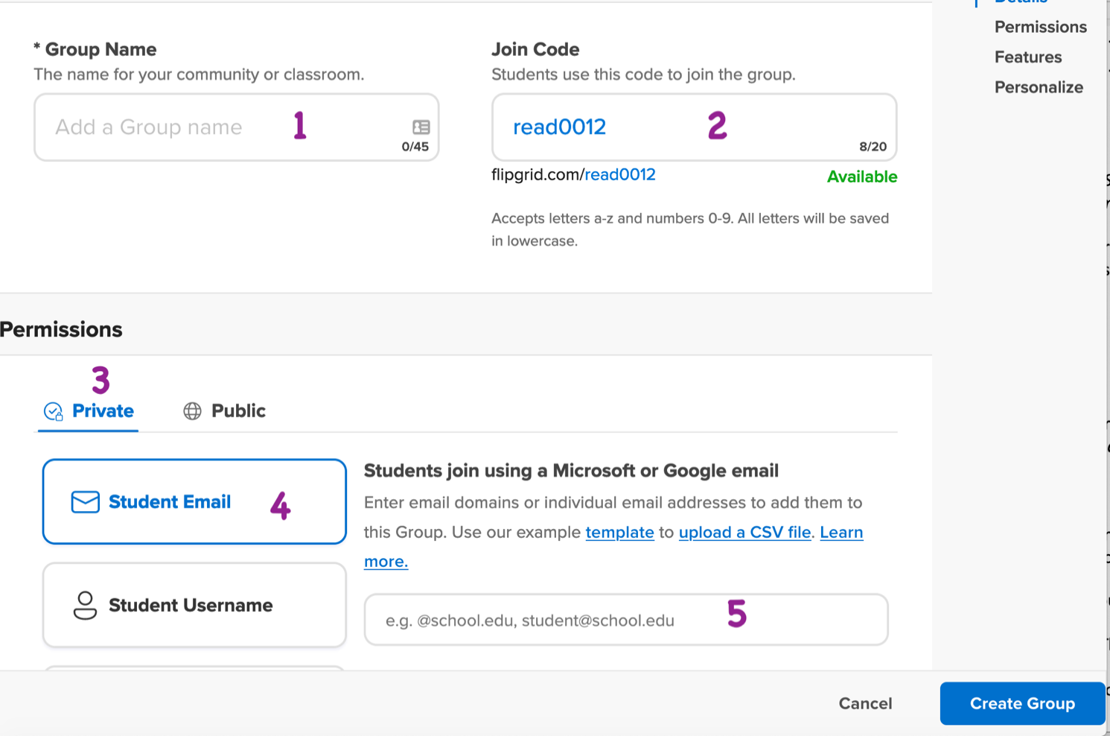

- Scroll down to allow following and to change the status of the group.

- Finally, you can personalize your group by adding a banner image. FlipGrid provides some options, but you can also upload your own.

- Be sure to click “Create Group” at the bottom.
- A pop-up will come up with directions for sharing. Click out of that window to begin making topics.

Topics
- A “grid” is a container. To add discussions, click on “Add New Topic.” (There is a default one available that you can edit or delete called, “Say Hello on Flipgrid!”.)
- On the “Create a New Topic” page,
  - Be sure to title your topic and provide a prompt of some sort, even if it is to reference directions elsewhere. You can add media resources as well.
  - Under “Permissions,” decide if the permissions for this topic should deviate from the overall group’s permissions.
  - Under “Essentials,” decide if you want to moderate the videos. This is off by default.
    - Decide how long participants’ recordings should be (from 15 seconds to 10 minutes).
    - Select how you want students to reply to each other’s videos: text and video, text or video, or none.
  - Under “Attachments,” you can add up to 9 external links. This might include examples, rubrics, etc.
  - Under “Topic Status,” indicate if the topic is active and/or set active dates.
  - Under “Notifications,” decide how you would like to receive notice that submissions have been made and/or if students are allowed to follow the topic activities.
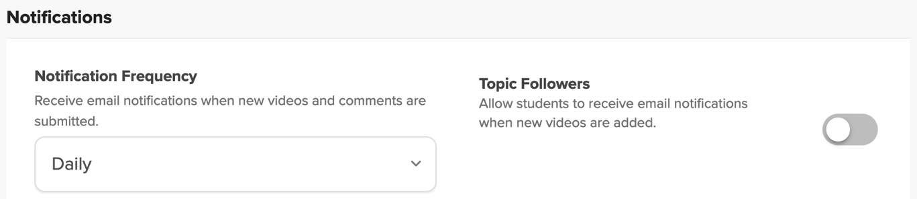
  - Video Features - options:
    - Video & Cover Image Effects – allows students to add filters, stickers, drawings, and text to their videos at any point in the recording and then take it away again at any point.
    - Video editing – basic trimming and adding recording if needed.
    - Attachment link – provides students a place to add a link to their presentation files.
    - View count – shows the number of times the video has been viewed.
    - Likes – allows students to like or “heart” each other’s videos without leaving comments.
    - Sticky Notes – allows the student to insert a sticky note at any point in the video and then take it away at any point as well.

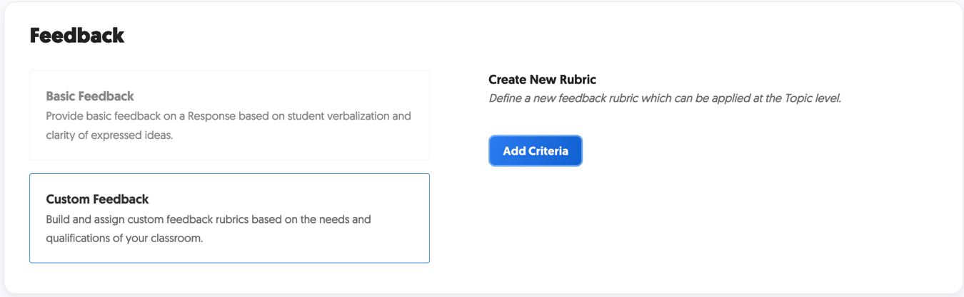
- Feedback – you can create a rubric within Flipgrid or leave basic feedback. (*Note: Currently these grades will not transfer to Canvas automatically. You could use Canvas Speedgrader to grade the discussion or assignment where the FlipGrid is embedded.)

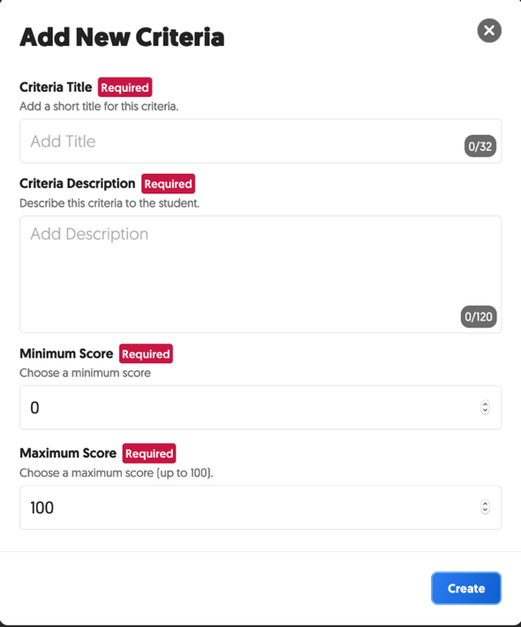

Embedding Flipgrid into Canvas
You can either link to or embed a FlipGrid Group (with all of its topics) or individual topics to Canvas. Typically, if the activity in the FlipGrid warrants a grade, you would want to link these in a discussion or module or in an individual assignment. Even if it is embedded in individual assignments, students will be able to access all student videos and make comments from their individual assignment pages.
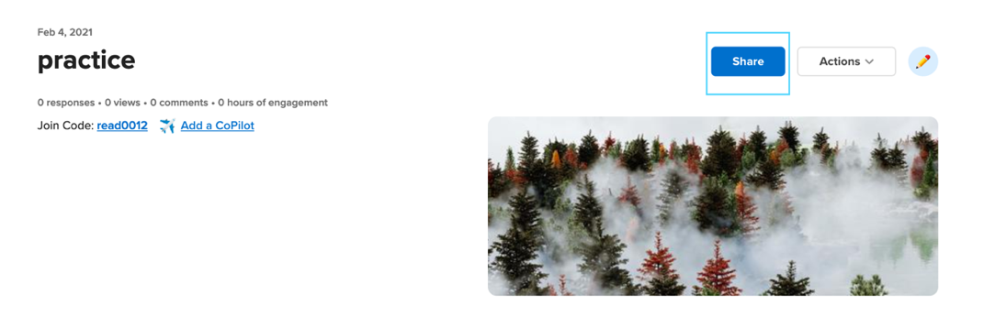

Group
To embed an entire group of topics:

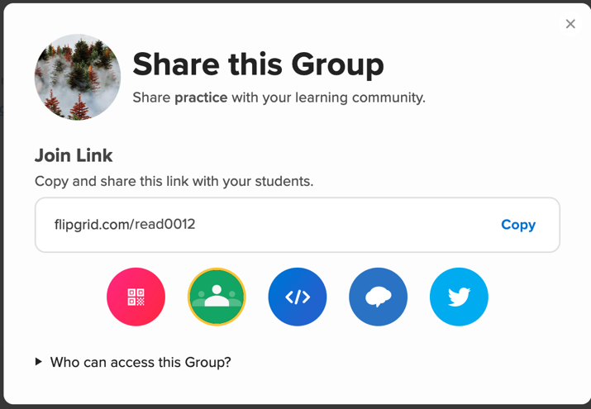
- Click on the “Share” button above the group banner.
- Click on the embed icon.
Doing so automatically copies the code to
your clipboard.

- Alternatively, if you don’t want to embed the
link, you can simply copy the “Join Link” and provide that to your students via email or announcements.

- If embedding, go to the place in Canvas where you want the FlipGrid group to appear.
Click “Edit” and look for the cloud icon. This may appear under a vertical ellipsis on some screens.
Then, paste the embed code in the box that appears.

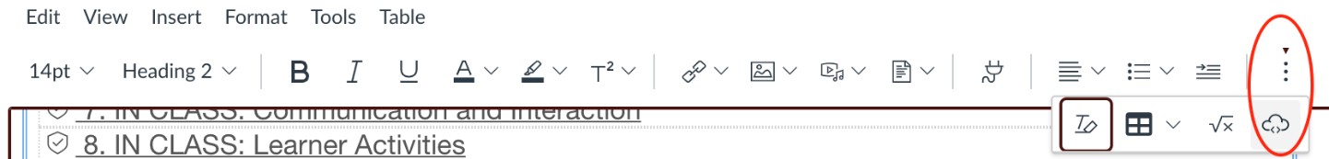

You can change the width up to 100% and the height to 900, 1000 + to encompass the whole embed window. This may be too large, however.

Topic

- Click “Share” to the right of the topic name.
- Then, click on the embed icon. Doing so automatically copies the code to your clipboard.
- Go to the place in Canvas where you want the Flipgrid to appear.
- Click “Edit” and look for the cloud icon. This may appear under a vertical ellipsis on some screens. Then, paste the embed code in the box that appears.

You can change the width up to 100% and the height to 900, 1000 + to encompass the whole embed window. This may end up too large, however.

Uploading/Recording to Flipgrid (as an instructor or student)

- Sign in to the Canvas course.
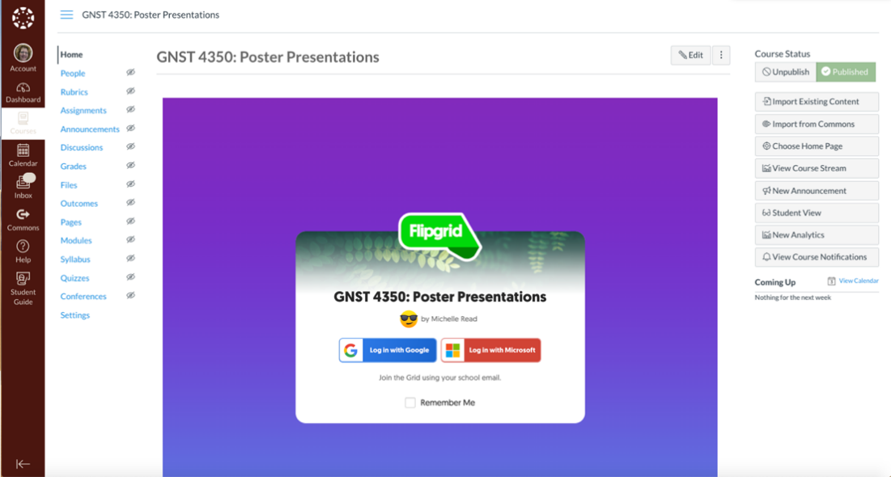

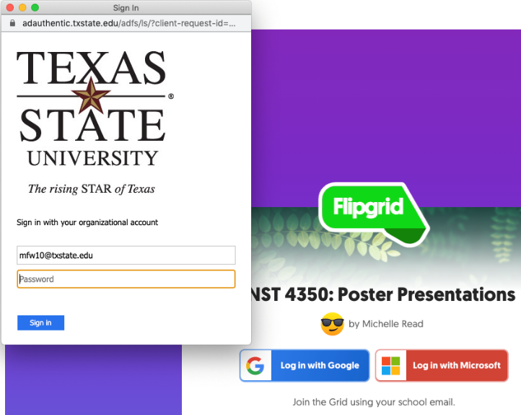
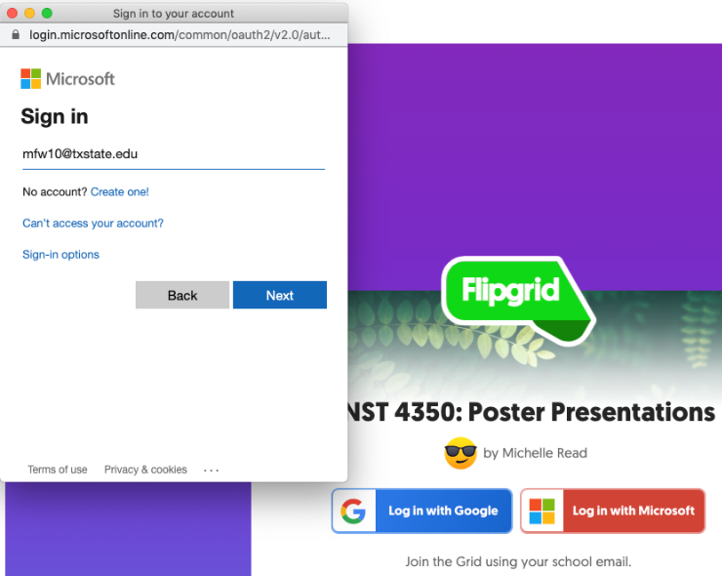
- Sign in to Flipgrid using your Microsoft Office 365 account (NetID, usual password). You will likely be redirected to the Texas State University SSO login.

- You should now see the Flipgrid interface.

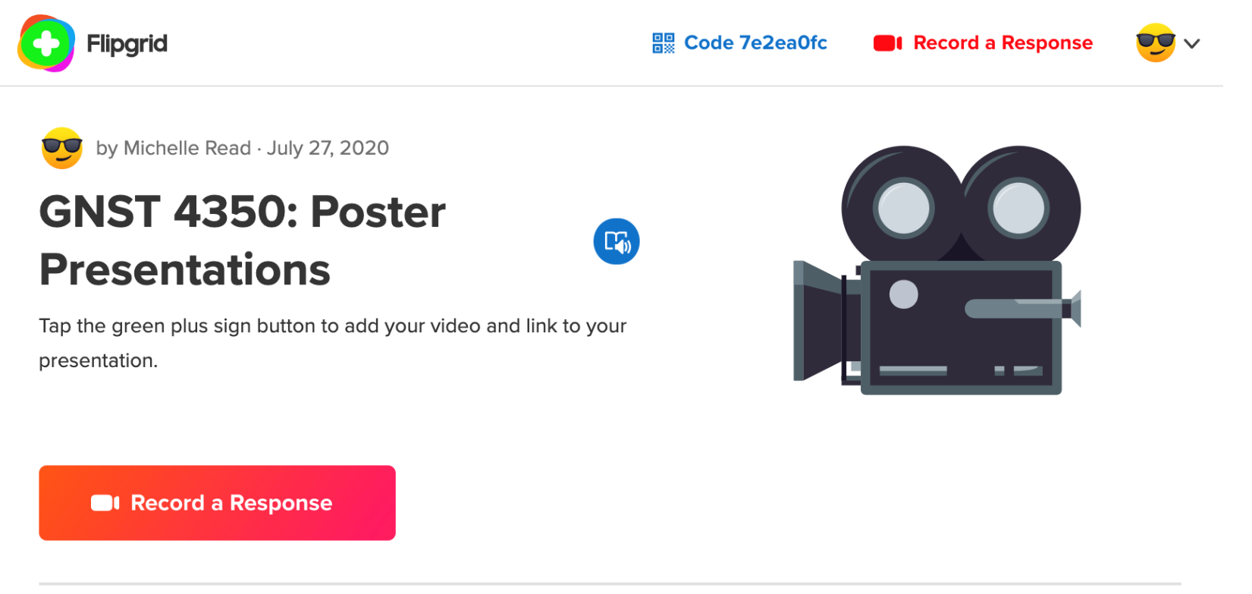

- Click on “Record a Response” to begin.

- Use the video wizard to either upload or record your video presentation. Click “Options” to the left of the red record button. *Note: The time limit set up by the instructor.

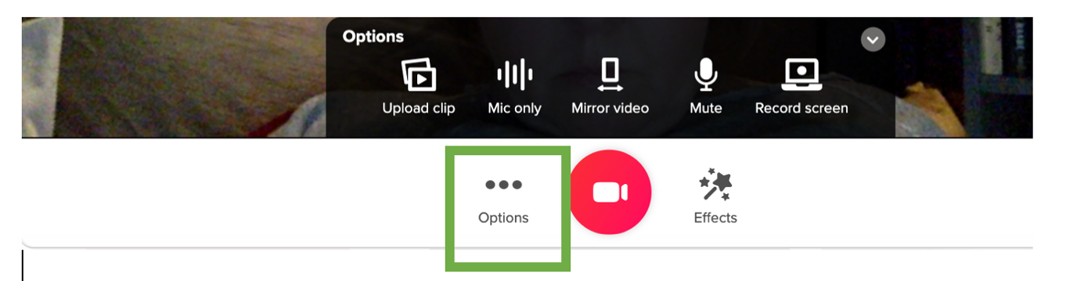
- As you are recording, you can add and take away sticky notes, images from your computer, drawings, and text boxes assuming the instructor has allowed this is the setup, by clicking the “Effects” option to the right of the red record button. Press “pause” each time you opt to add or remove one of these elements and then record to continue.
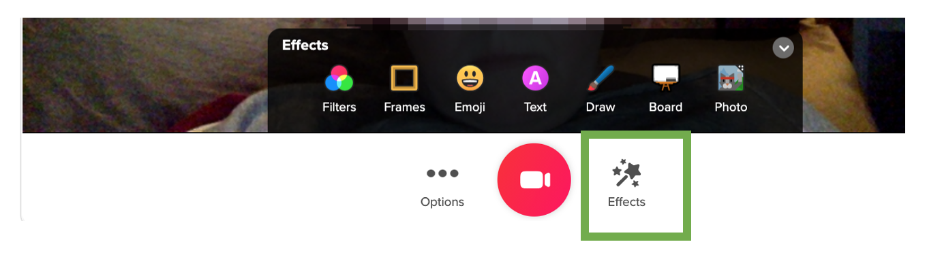
- Review your recording. Trim or add onto if/as necessary (Assuming this possibility has been turned on by the instructor).
- Take a selfie to serve as a splash-screen to your video.
- Finally, on the last screen of the wizard add your name, the title of your presentation, and a link to your presentation files or folder of files in Microsoft 365 (see next section on sharing a document in Microsoft 365). The ability to add links to a presentation file must be turned on by the instructor when setting up the Flipgrid topic.
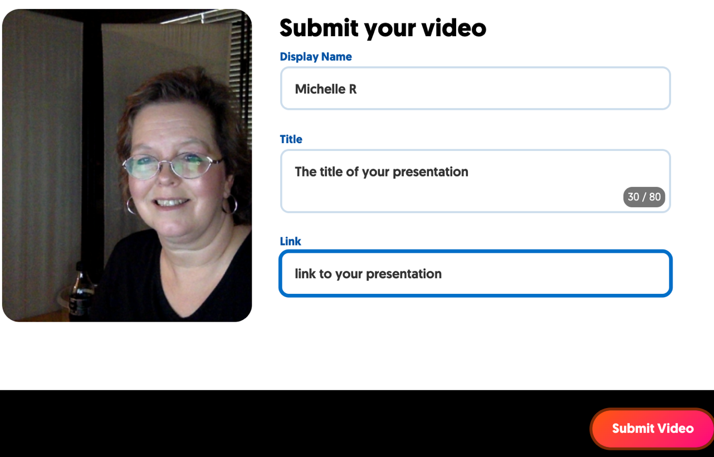

Alternatives to Video

You can allow students to:

- Create a whiteboard or blackboard animation. Click “Effects” and “Board” which allows for a split-screen with the author on one side and the board on the other.
- Simply record a drawing by clicking “Effects” and “Draw”. The split-screen option is available for this tool as well. This is really good for demonstrating your attempts to solve equations, complete science experiments, or teach drawing skills.
- Create a screen recording with the recorders image in the corner. To select, click the “Options” button to the left of the red record icon. Choose the screen you wish to record.
- Create a silent film if you turned off the audio. J

Responding to Students in Flipgrid

- Once your peers have begun adding their videos, you will see their selfie splash screens appear next to the green plus (+) sign. Simply click on their pictures to watch their video.
- You can download their slides or other documents (or view their websites) by clicking the document icon in the top right corner.
- Click the comment spaces below the video to leave a text or video comment, depending on your settings.

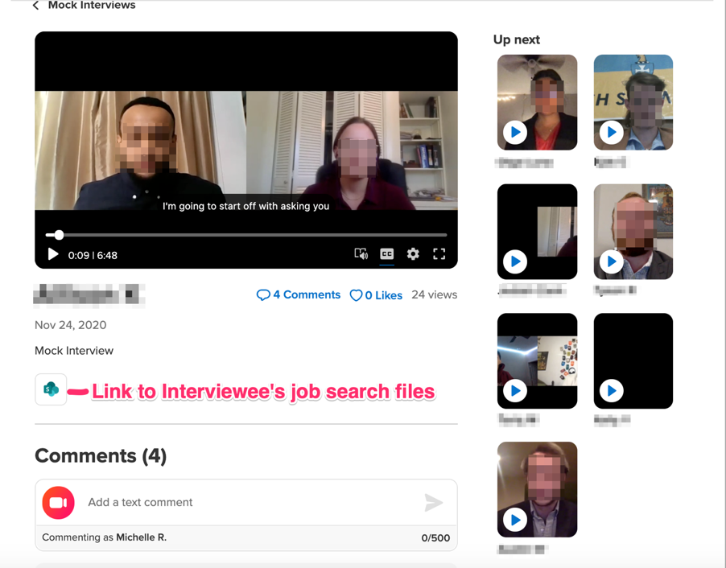

Sharing a Microsoft 365 Document
These notes are good for you or your students.

- Upload your files.

- Share. Click the ellipsis (…) next to the title of your uploaded presentation document. Choose “Share.” On the pop-up “Link settings,” chose “People in Texas State University with the link” and uncheck “Allow editing.” Leave “Block download” set to off. Then click “Apply.”
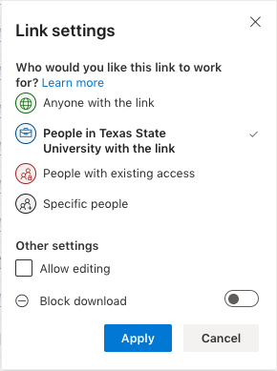
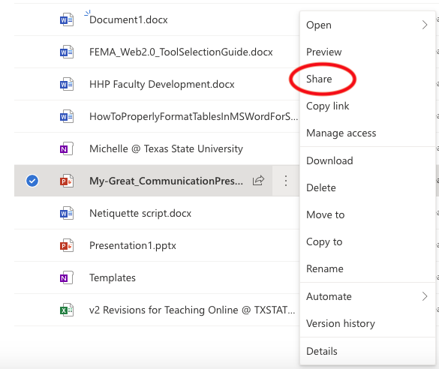

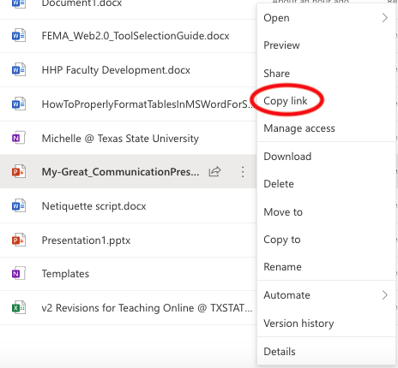
- Return to the ellipsis (…) next to the title of your uploaded presentation document. Choose “Copy link”. Paste this link in the Flipgrid final slide before submitting, under “Link”.
- *Note: You can also share an entire folder of files by following the same steps.

